# EXPERIMENTAL STUDIES ON CONTROLLED LOW STRENGTH MATERIAL USING STONE DUST

**AND EXPANDED POLYSTYRENE BEADS**

*This project report is submitted to*

*Rashtrasant Tukadoji Maharaj Nagpur University*

*in the partial fulfilment of the requirement for the award of the degree of*

**Bachelor of Engineering in Civil Engineering**

*by*

**Mr. Ravi D. Singh (CE18103)**

**Ms. Ramya R. Panocker (CE18104)**

**Mr. Kapil V. Humne (CE18107)**

**Mr. Suhas D. Sikchi (CE18112)**

*Under the guidance of*

**Mr. Rajesh K. Parve**

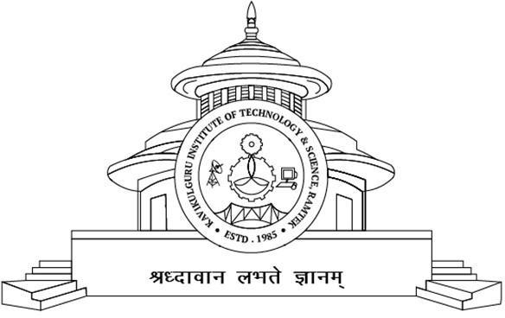 Assistant Professor

**2022-2023**

DEPARTMENT OF CIVIL ENGINEERING

KAVIKULGURU INSTITUTE OF TECHNOLOGY AND SCIENCE

RAMTEK, NAGPUR, MAHARASHTRA, INDIA-441 106

**KAVIKULGURU INSTITUTE OF TECHNOLOGY AND SCIENCE**

**RAMTEK, NAGPUR M.S., INDIA-441 106**

**DEPARTMENT OF CIVIL ENGINEERING**

**CERTIFICATE**

This is to certify that the project report entitled **‘Experimental Studies on Controlled Low Strength Material using Stone Dust and Expanded Polystyrene (EPS) Beads’** carried out by Mr. Ravi D. Singh (CE18103), Ms. Ramya R. Panicker (CE18104), Mr. Kapil V. Humne (CE18107) and Mr. Suhas D. Sikchi (CE18112) of the B.E/B.Tech.. final year of civil engineering, during the academic year 2022-2023, in the partial fulfilment of the requirement for the award of the degree of **Bachelor of Engineering/Bachelor of Technology (Civil Engineering)** offered by the **Rashtrasant Tukadoji Maharaj Nagpur University,** Nagpur.

Mr. Rajesh K. Parve

**Guide**

Dr. A. N. Dabhade Dr. Avinash Shrikhande

**Head of the Department Principal**

Date:

Place: Ramtek